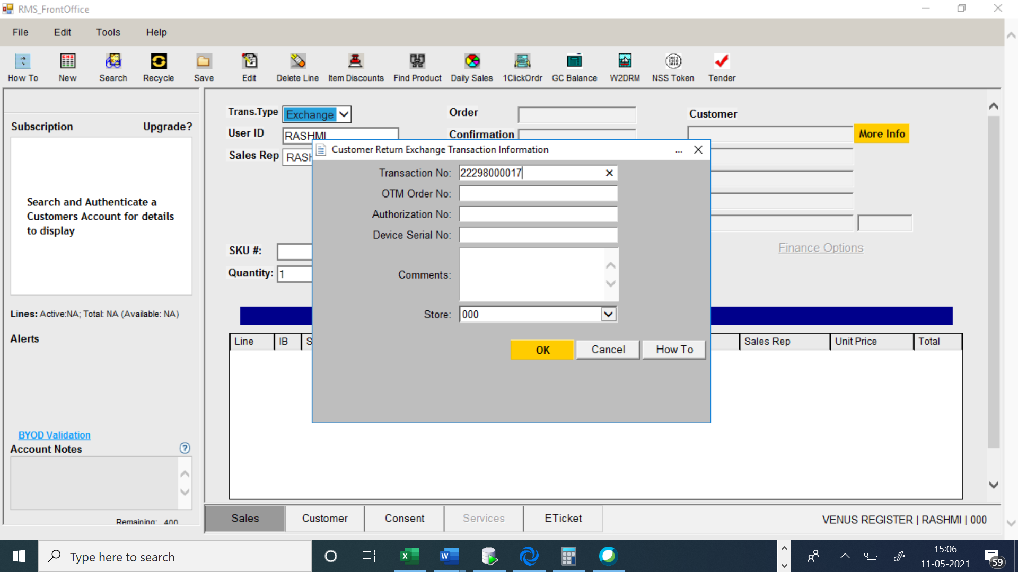

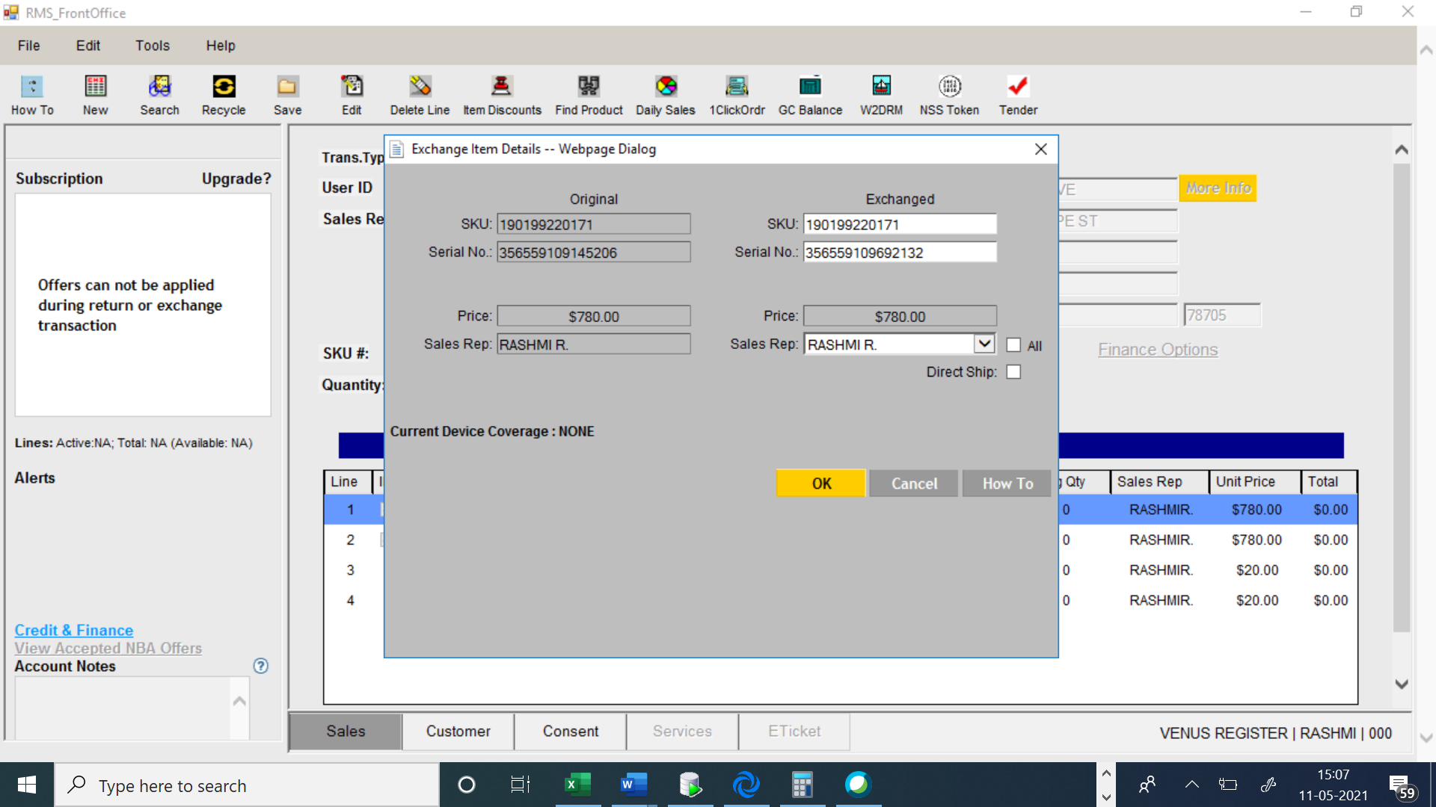

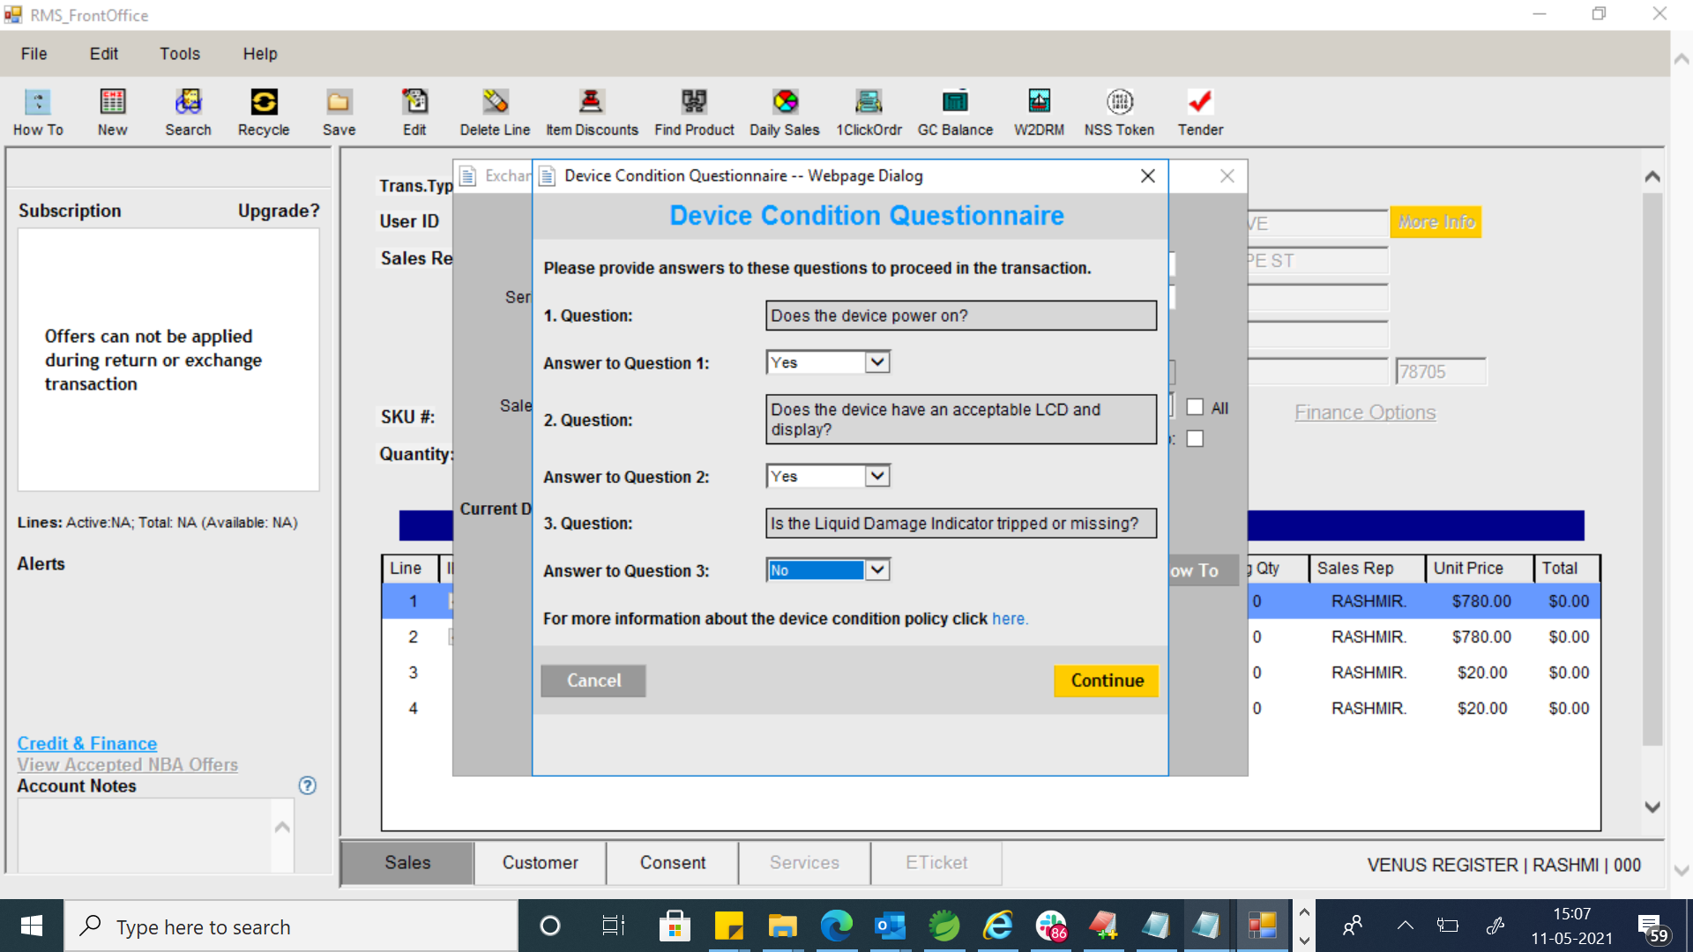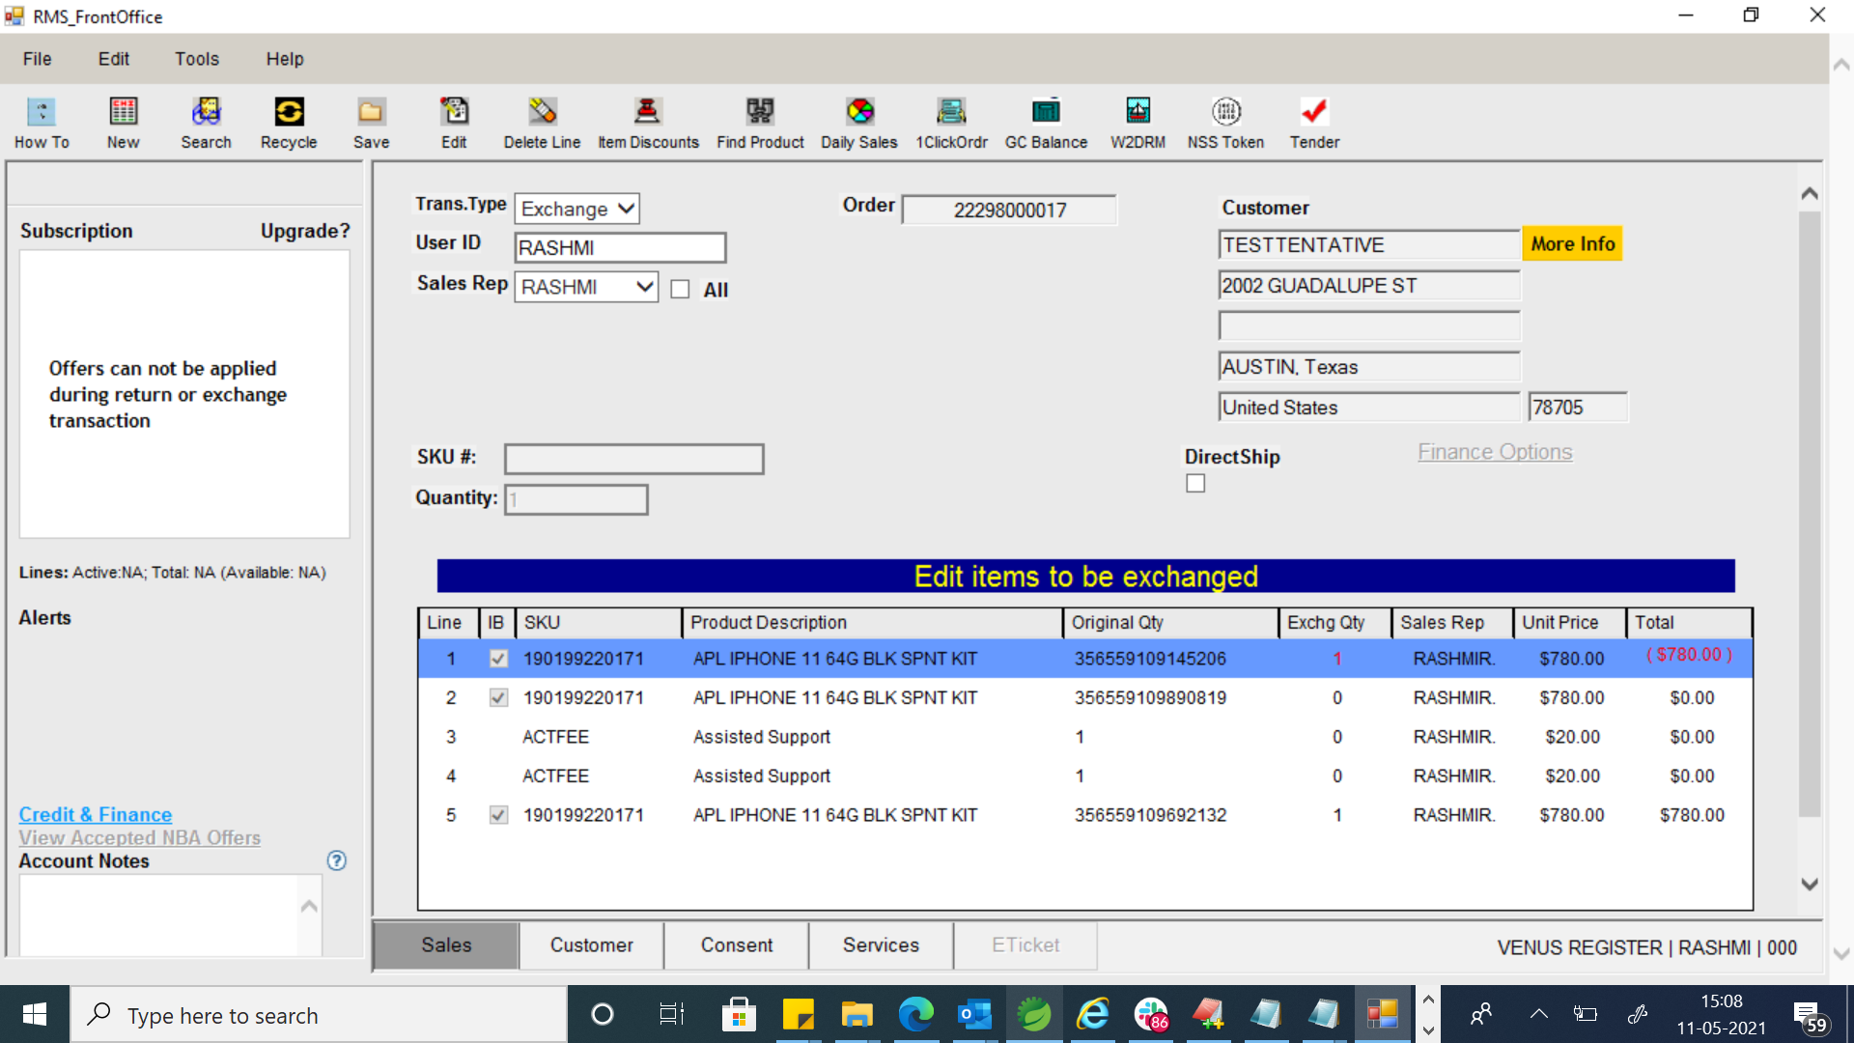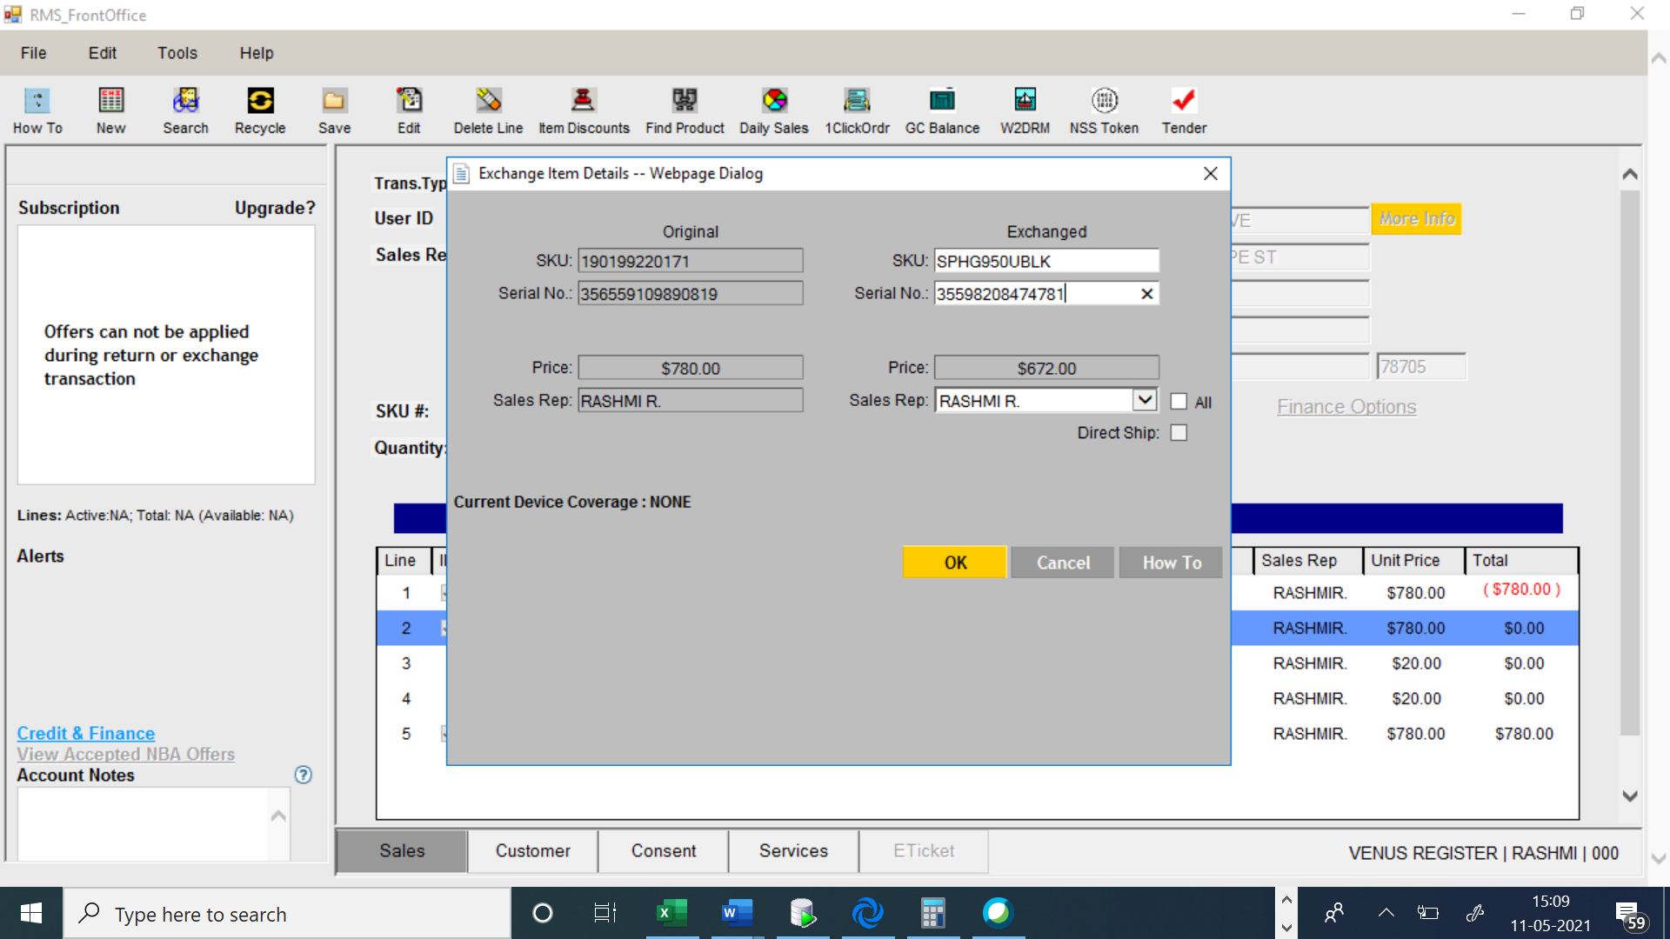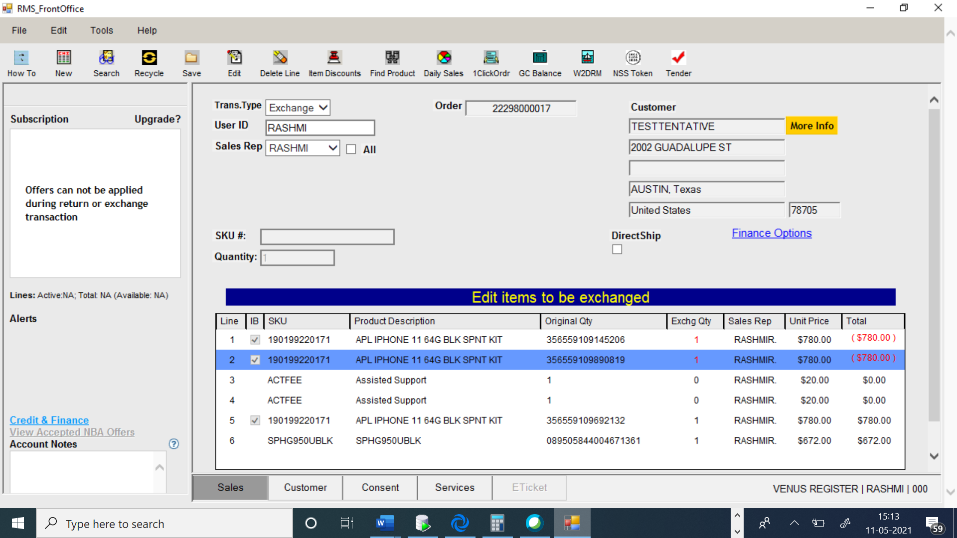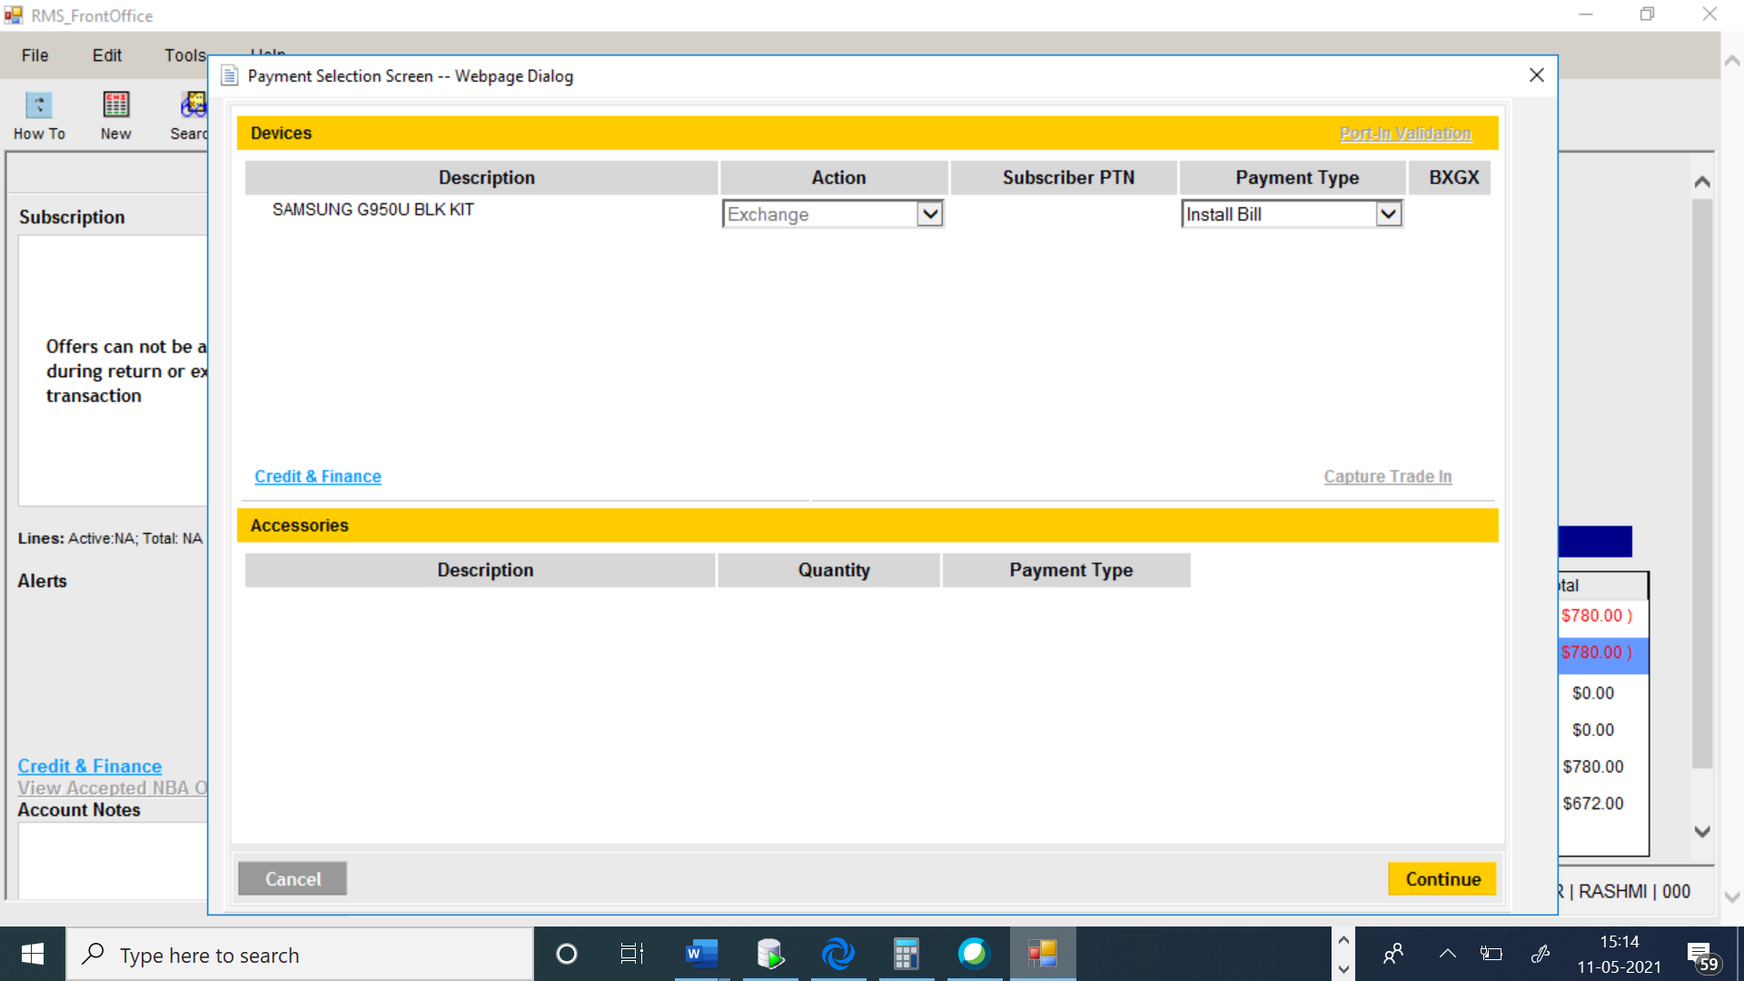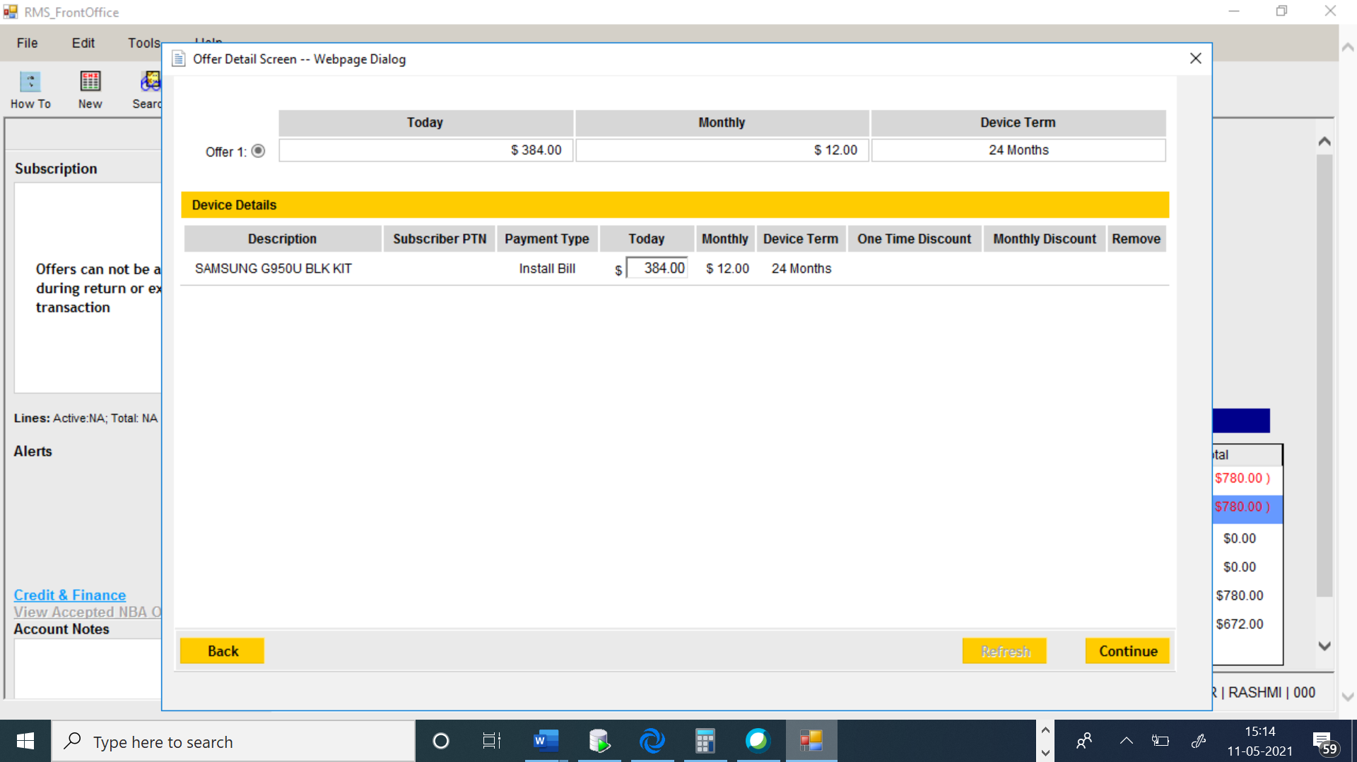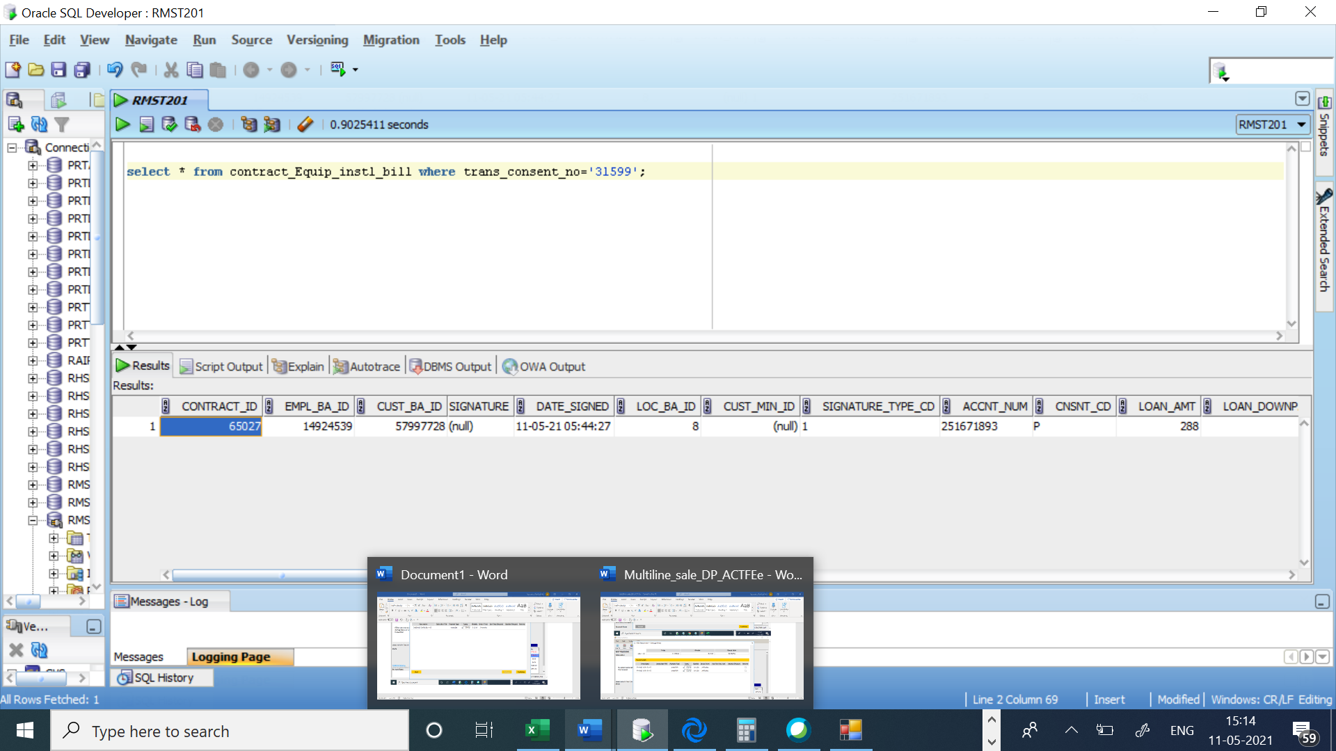

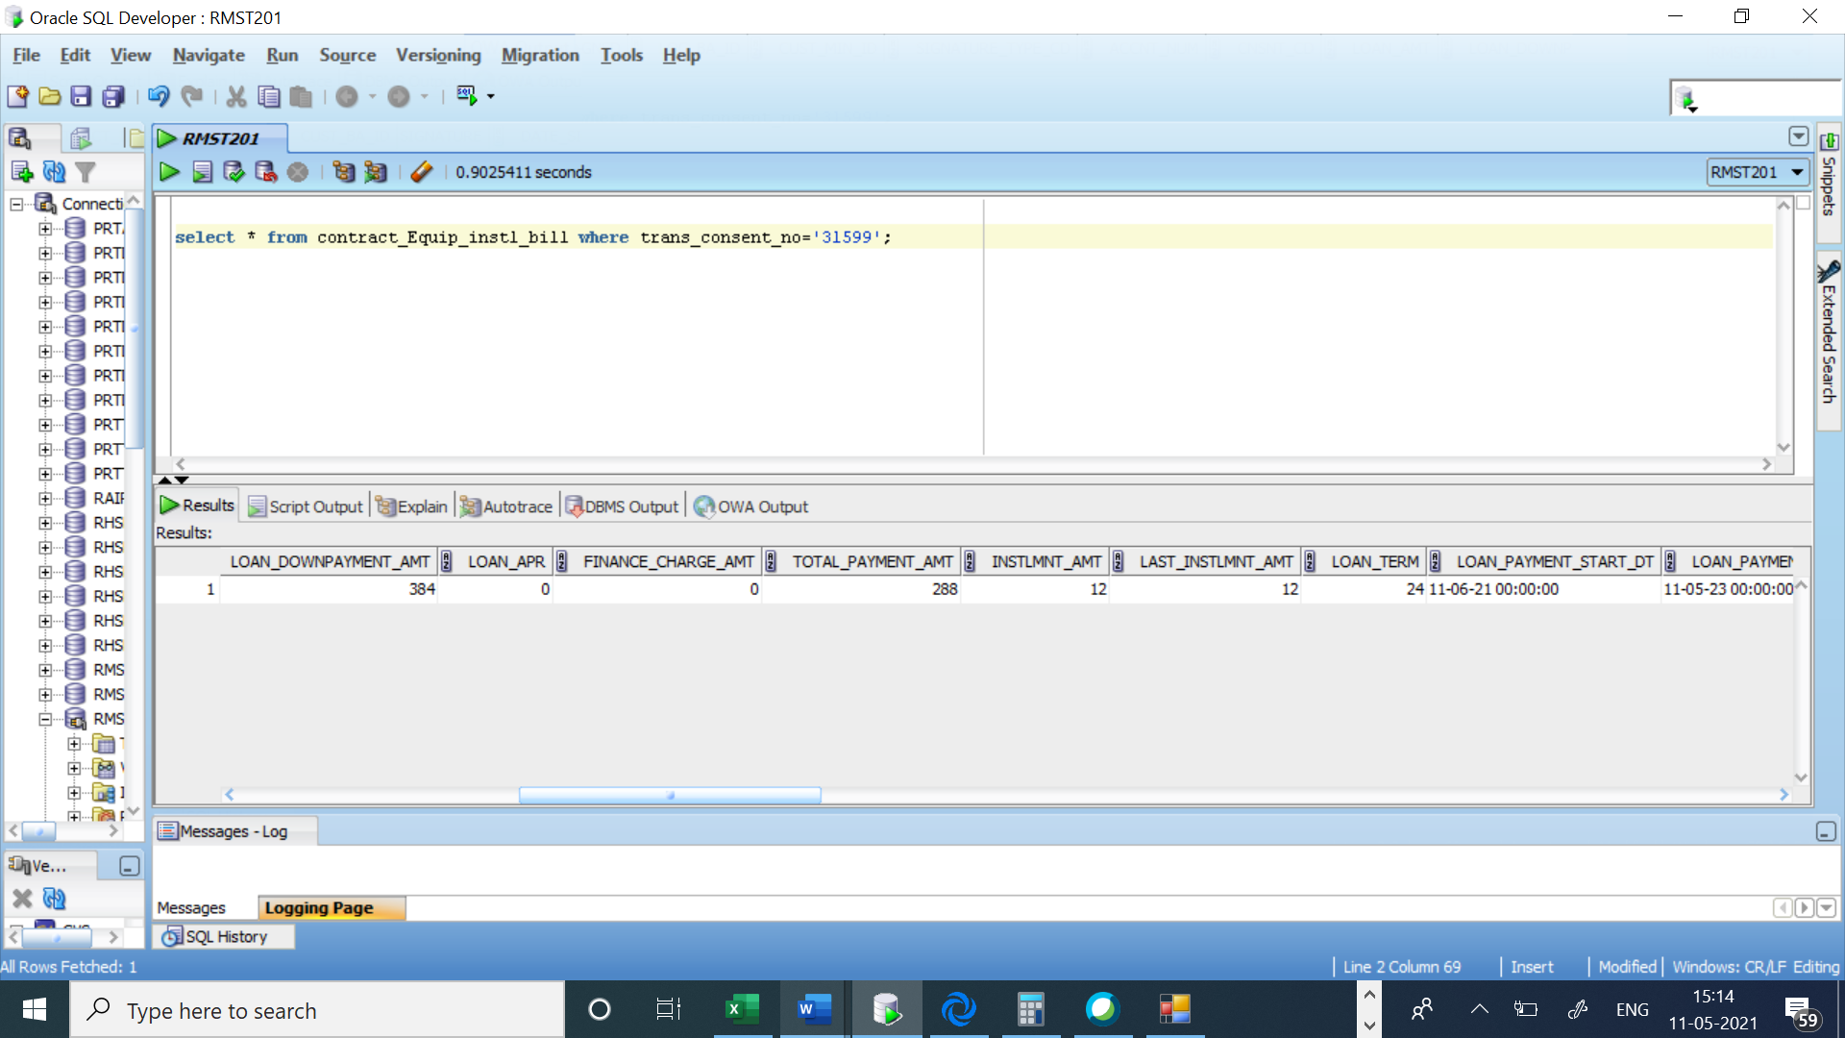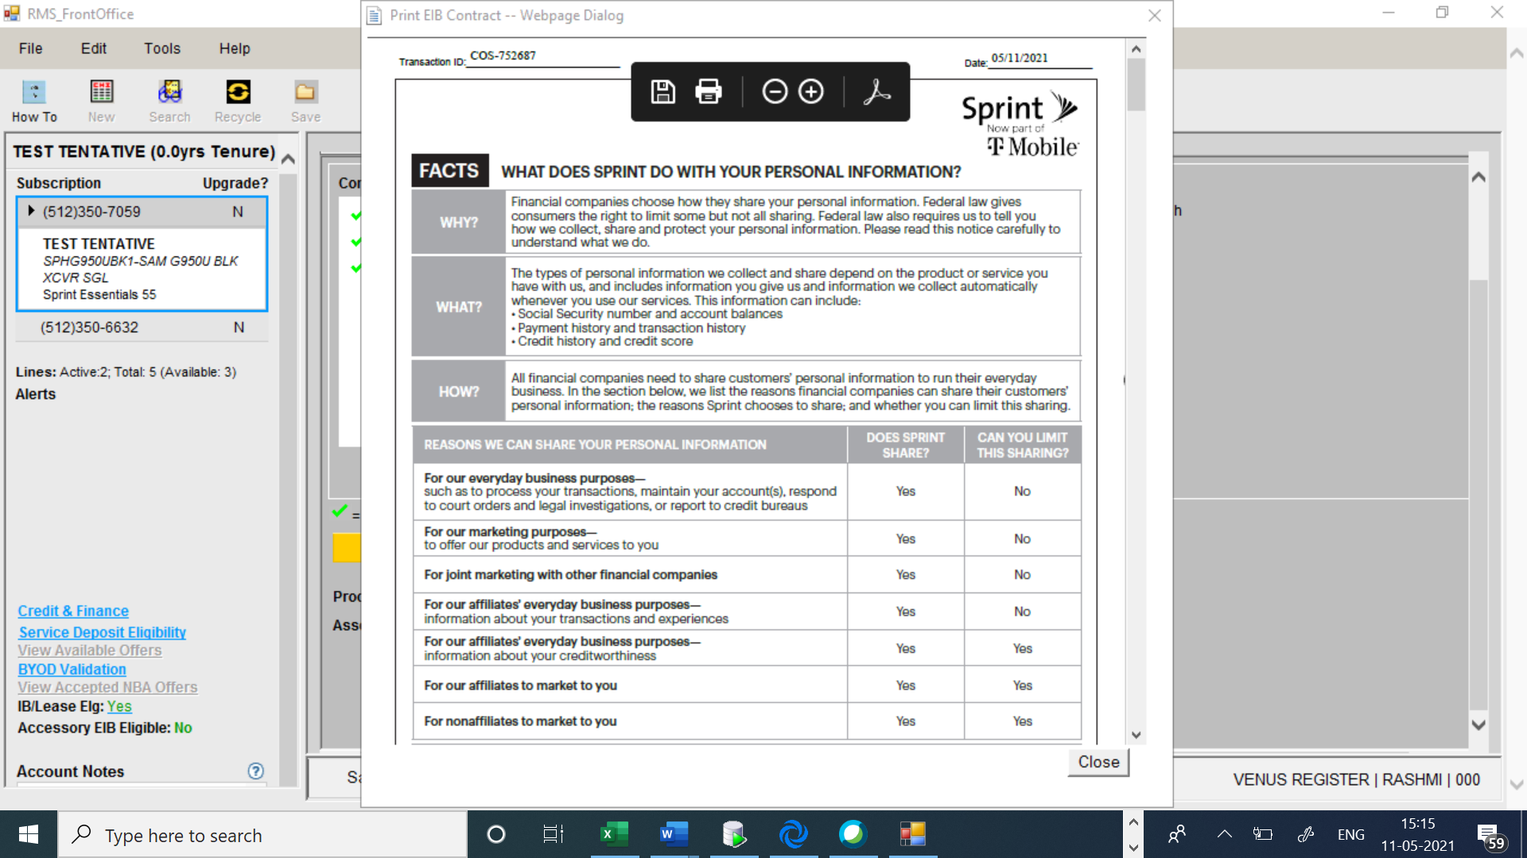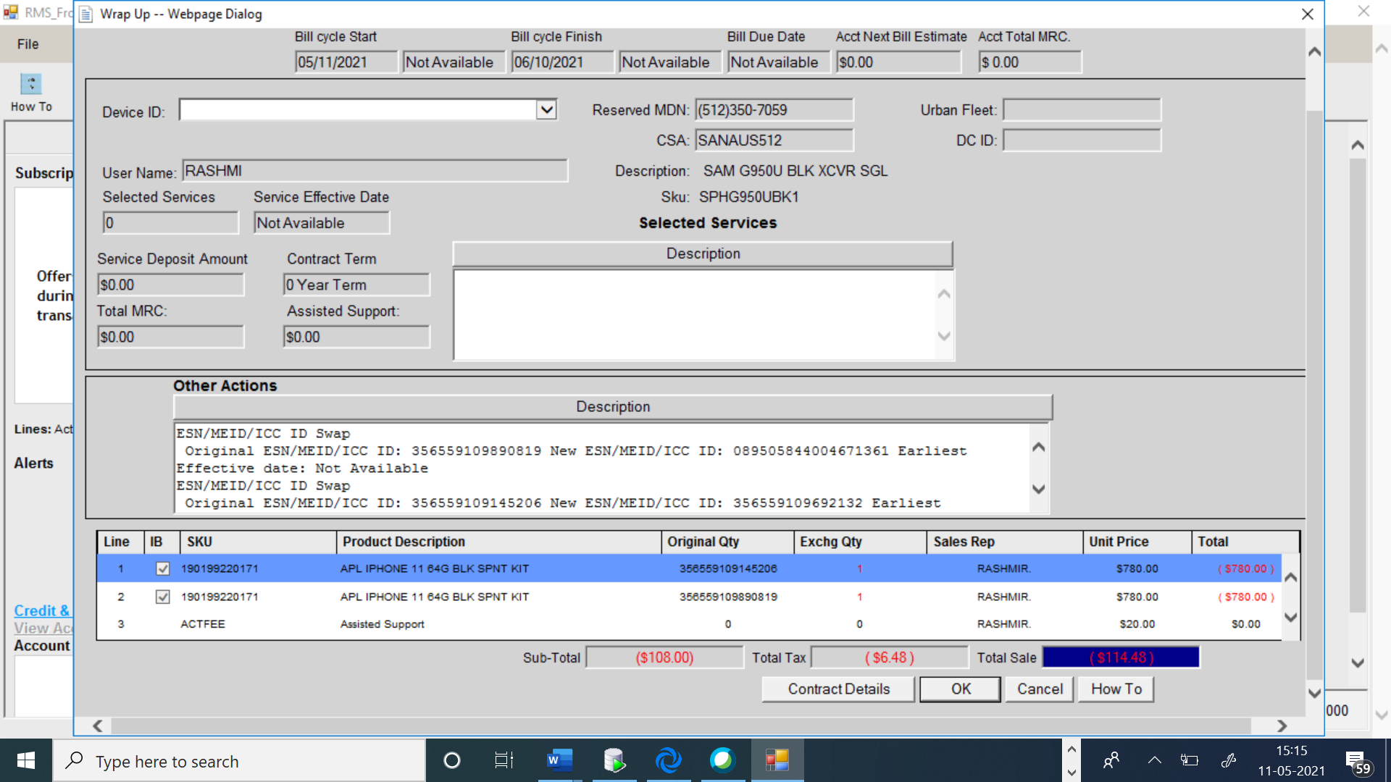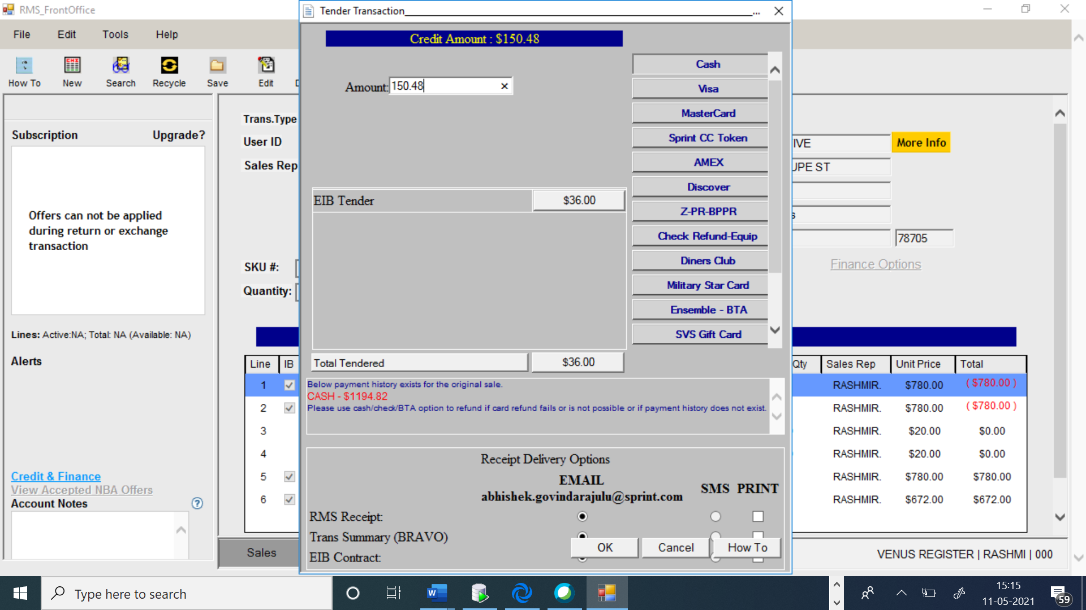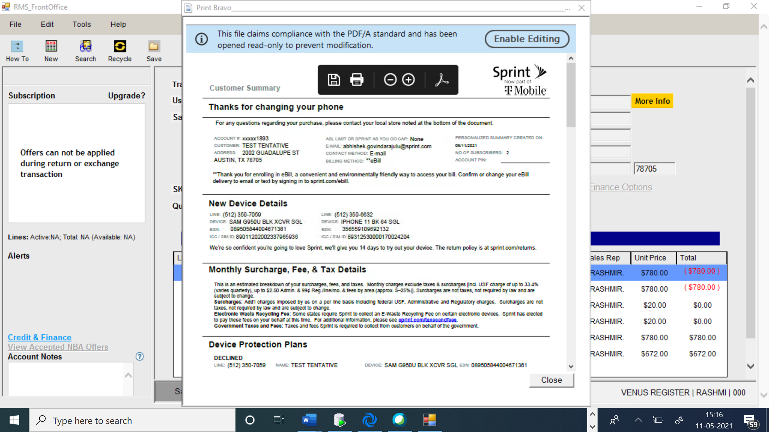

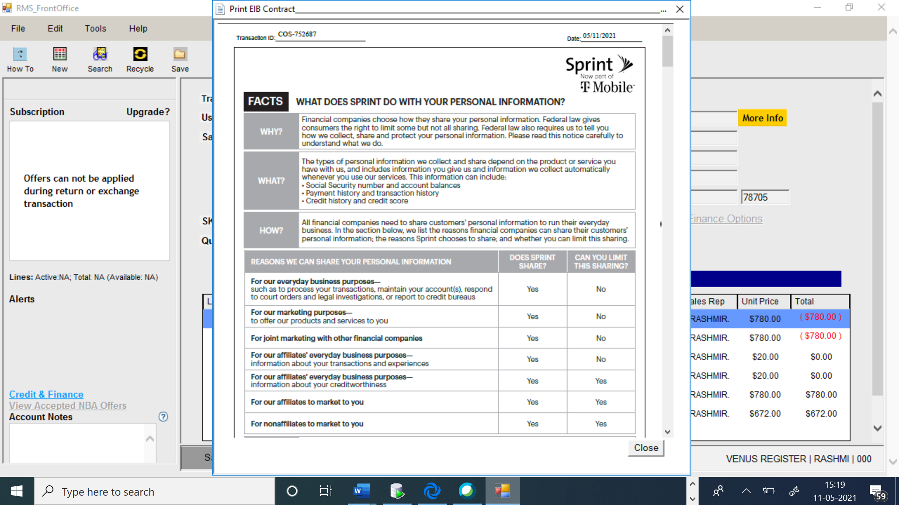

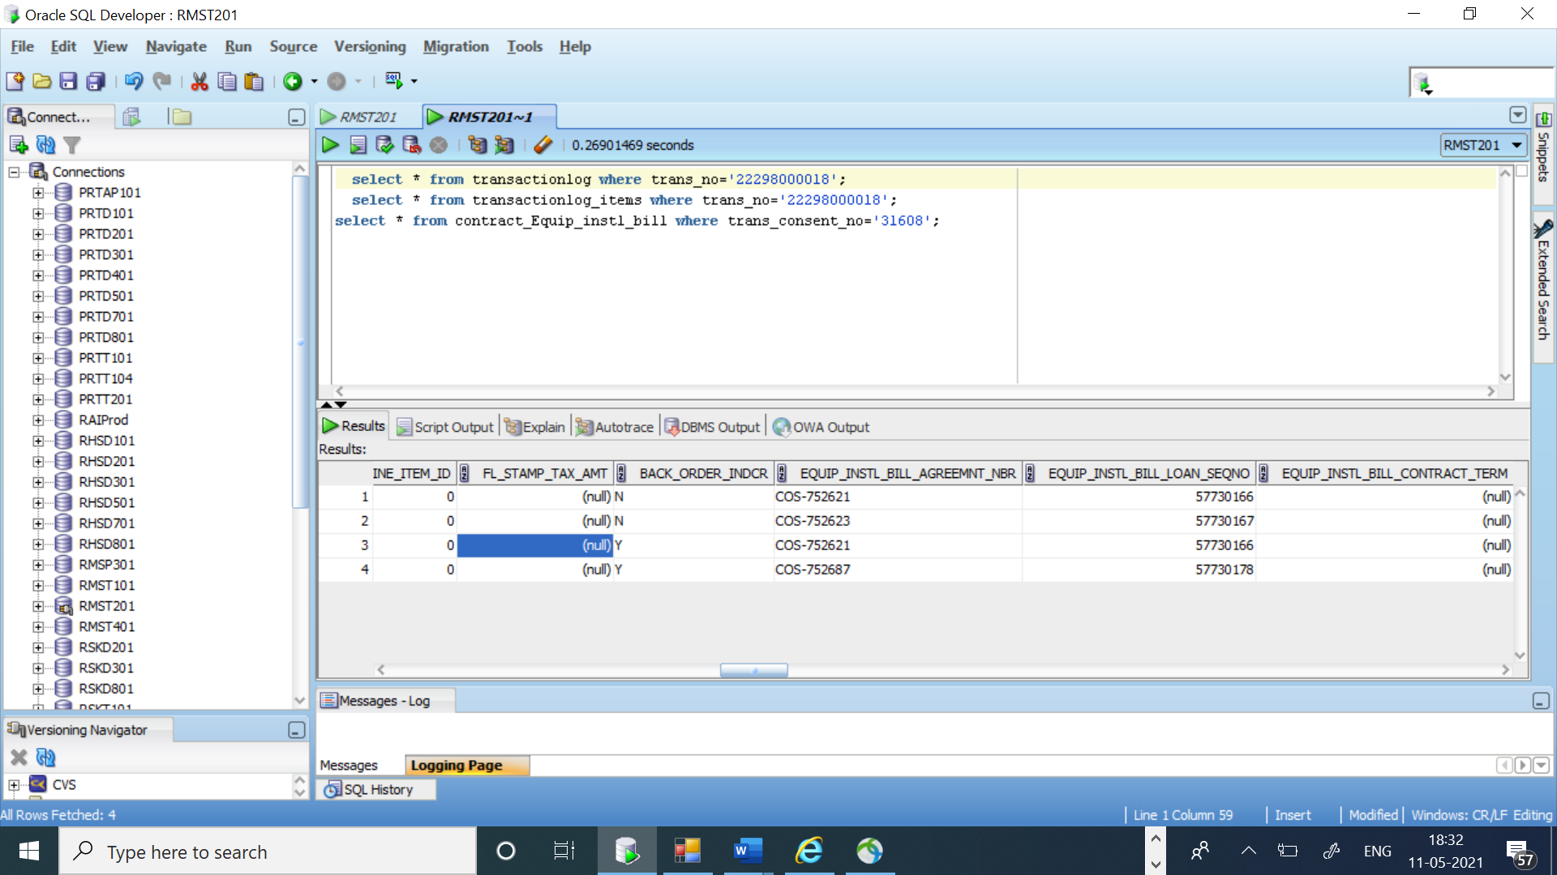

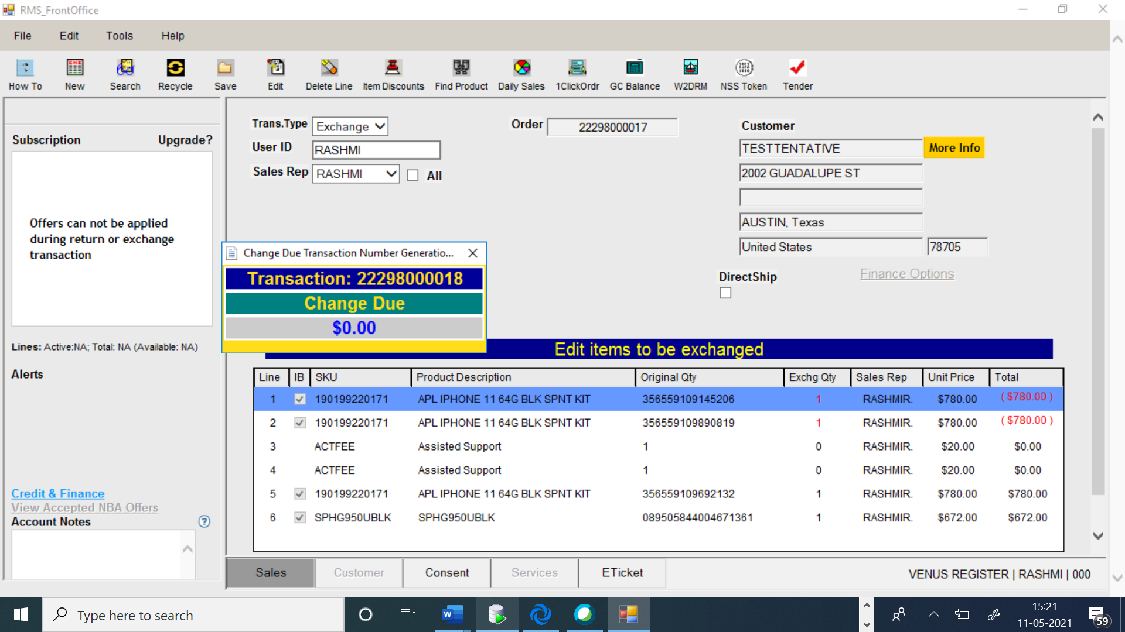

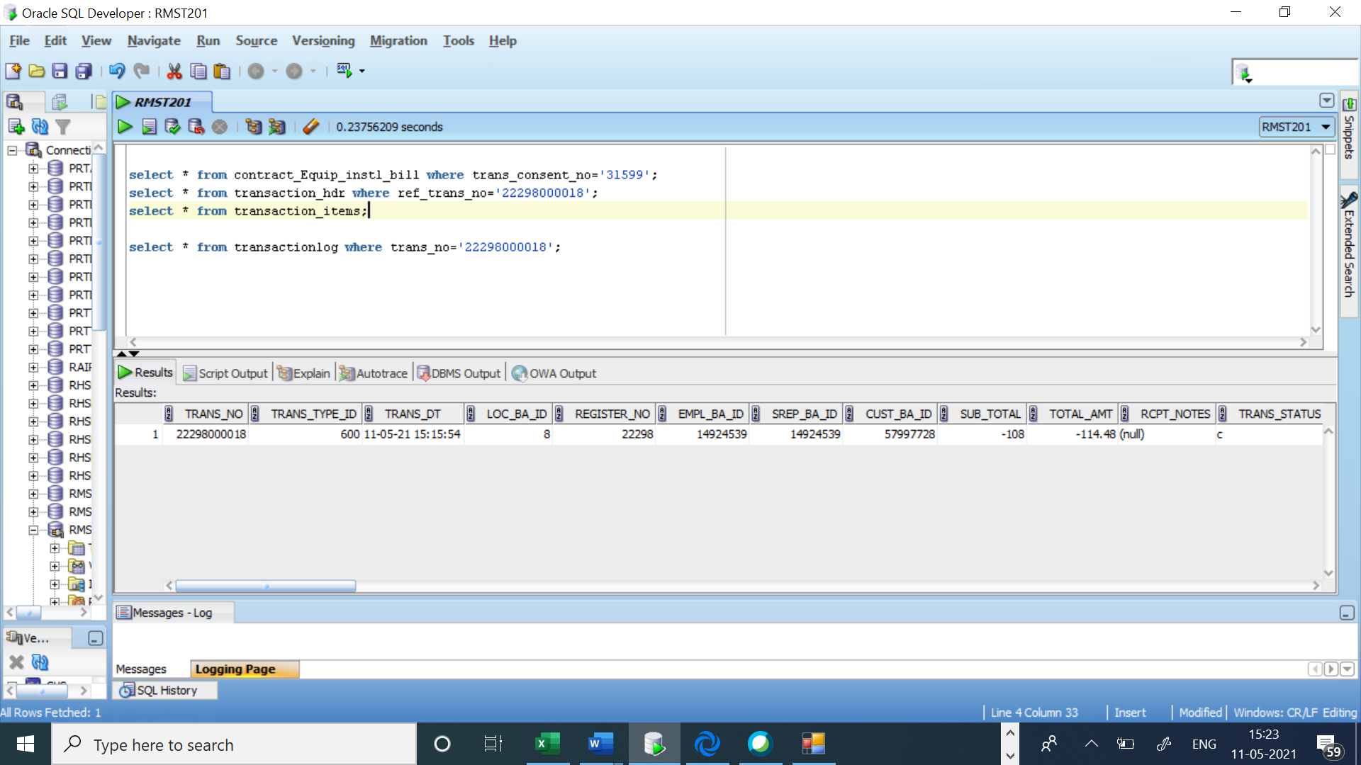

20210511|05:46:04.864|RASHMI|XML Request for updateLoan API

<tns:wsMessageHeader xmlns:tns="http://integration.sprint.com/common/header/WSMessageHeader/v2"><tns:trackingMessageHeader><tns:applicationId>RHS</tns:applicationId><tns:applicationUserId>System</tns:applicationUserId><tns:consumerId></tns:consumerId><tns:messageId>RHS:370370012</tns:messageId><tns:conversationId>3421</tns:conversationId><tns:timeToLive>45</tns:timeToLive><tns:messageDateTimeStamp>2021-05-11T05:46:03</tns:messageDateTimeStamp></tns:trackingMessageHeader></tns:wsMessageHeader>

<tns:updateLoan xmlns:tns="http://integration.sprint.com/interfaces/updateLoan/v1/updateLoan.xsd"><tns:accountInfo><tns:subscriberId>98974610221</tns:subscriberId></tns:accountInfo><tns:loanInfo><tns:loanSequenceNumber>57730167</tns:loanSequenceNumber><tns:activityCode>S</tns:activityCode><tns:loanUpdateDetails><tns:loanStatusUpdateDetails><tns:loanStatus>N</tns:loanStatus><tns:loanStatusReasonCode>RTALEQ</tns:loanStatusReasonCode><tns:ssgDetailsInfoList><tns:ssgDetailsInfo><tns:orderLineNumber>2</tns:orderLineNumber><tns:ssgReturnSourceSystemAppId>RHS</tns:ssgReturnSourceSystemAppId><tns:ssgReturnDate>2021-05-11T05:46:03Z</tns:ssgReturnDate><tns:ssgReturnTransactionId>22298000018</tns:ssgReturnTransactionId></tns:ssgDetailsInfo></tns:ssgDetailsInfoList></tns:loanStatusUpdateDetails></tns:loanUpdateDetails></tns:loanInfo></tns:updateLoan>

20210511|05:46:04.864|RASHMI|XML Reply for updateLoan API

<?xml version="1.0" encoding="UTF-8"?><SOAP-ENV:Envelope xmlns:xsd="http://www.w3.org/2001/XMLSchema" xmlns:xsi="http://www.w3.org/2001/XMLSchema-instance" xmlns:SOAP-ENC="http://schemas.xmlsoap.org/soap/encoding/" xmlns:SOAP-ENV="http://schemas.xmlsoap.org/soap/envelope/"><SOAP-ENV:Header><m:wsMessageHeader xmlns:m="http://integration.sprint.com/common/header/WSMessageHeader/v2"><m:trackingMessageHeader><m:applicationId>RHS</m:applicationId><m:applicationUserId>System</m:applicationUserId><m:consumerId/><m:messageId>RHS:370370012</m:messageId><m:conversationId>3421</m:conversationId><m:timeToLive>45</m:timeToLive><m:replyCompletionCode>0</m:replyCompletionCode><m:messageDateTimeStamp>2021-05-11T05:46:04-04:00</m:messageDateTimeStamp></m:trackingMessageHeader></m:wsMessageHeader></SOAP-ENV:Header><SOAP-ENV:Body><upd1:updateLoanResponse xmlns:upd="http://integration.sprint.com/integration/interfaces/updateLoanBtV1/v1/updateLoanBtV1" xmlns:upd1="http://integration.sprint.com/interfaces/updateLoan/v1/updateLoan.xsd"> <upd1:message>Successful</upd1:message> </upd1:updateLoanResponse></SOAP-ENV:Body></SOAP-ENV:Envelope>

20210511|05:46:05.252|RASHMI|XML Request for createLoan API

<tns:wsMessageHeader xmlns:tns="http://integration.sprint.com/common/header/WSMessageHeader/v2"><tns:trackingMessageHeader><tns:applicationId>RHS</tns:applicationId><tns:applicationUserId>System</tns:applicationUserId><tns:consumerId></tns:consumerId><tns:messageId>RHS:734896578</tns:messageId><tns:conversationId>3421</tns:conversationId><tns:timeToLive>45</tns:timeToLive><tns:messageDateTimeStamp>2021-05-11T05:46:04</tns:messageDateTimeStamp></tns:trackingMessageHeader></tns:wsMessageHeader>

<tns:createLoan xmlns:tns="http://integration.sprint.com/interfaces/createLoan/v1/createLoan.xsd"><tns:accountInfo><tns:subscriberId>98974610221</tns:subscriberId></tns:accountInfo><tns:loanInfo><tns:loanNumber>COS-752687</tns:loanNumber><tns:subscriberId>98974610221</tns:subscriberId><tns:loanDate>2021-05-11</tns:loanDate><tns:downPaymentAmount>384</tns:downPaymentAmount><tns:loanAmountFinanced>288</tns:loanAmountFinanced><tns:loanTerm>24</tns:loanTerm><tns:dealerCode>LAWND01X</tns:dealerCode><tns:transactionId>22298000018</tns:transactionId><tns:transactionDate>2021-05-11T05:46:04Z</tns:transactionDate><tns:installmentAmount>12</tns:installmentAmount><tns:previousInstallmentAmount>12</tns:previousInstallmentAmount><tns:loanType>D</tns:loanType><tns:loanModel>S</tns:loanModel><tns:loanItemsList><tns:loanItemsInfo><tns:itemId>SPHG950UBK1</tns:itemId><tns:quantity>1</tns:quantity><tns:downPaymentAmount>384</tns:downPaymentAmount><tns:loanAmount>288</tns:loanAmount><tns:transactionLineNumber>6</tns:transactionLineNumber><tns:deviceSerialNumber>089505844004671361</tns:deviceSerialNumber></tns:loanItemsInfo></tns:loanItemsList><tns:contractType>I</tns:contractType></tns:loanInfo></tns:createLoan>

20210511|05:46:05.252|RASHMI|XML Reply for createLoan API

<?xml version="1.0" encoding="UTF-8"?><SOAP-ENV:Envelope xmlns:SOAP-ENV="http://schemas.xmlsoap.org/soap/envelope/" xmlns:SOAP-ENC="http://schemas.xmlsoap.org/soap/encoding/" xmlns:xsi="http://www.w3.org/2001/XMLSchema-instance" xmlns:xsd="http://www.w3.org/2001/XMLSchema"><SOAP-ENV:Header><m:wsMessageHeader xmlns:m="http://integration.sprint.com/common/header/WSMessageHeader/v2"><m:trackingMessageHeader><m:applicationId>RHS</m:applicationId><m:applicationUserId>System</m:applicationUserId><m:consumerId/><m:messageId>RHS:734896578</m:messageId><m:conversationId>3421</m:conversationId><m:timeToLive>45</m:timeToLive><m:replyCompletionCode>0</m:replyCompletionCode><m:messageDateTimeStamp>2021-05-11T05:46:05-04:00</m:messageDateTimeStamp></m:trackingMessageHeader></m:wsMessageHeader></SOAP-ENV:Header><SOAP-ENV:Body><cre1:createLoanResponse xmlns:cre1="http://integration.sprint.com/interfaces/createLoan/v1/createLoan.xsd" xmlns:cre="http://integration.sprint.com/integration/interfaces/createLoanBtV1/v1/createLoanBtV1"> <cre1:loanSequenceNumber>57730178</cre1:loanSequenceNumber> <cre1:loanLastCycleCloseDate>2023-05-10</cre1:loanLastCycleCloseDate> </cre1:createLoanResponse></SOAP-ENV:Body></SOAP-ENV:Envelope>

20210511|05:46:12.786|RASHMI|XML Request for updateLoan API

<tns:wsMessageHeader xmlns:tns="http://integration.sprint.com/common/header/WSMessageHeader/v2"><tns:trackingMessageHeader><tns:applicationId>RHS</tns:applicationId><tns:applicationUserId>System</tns:applicationUserId><tns:consumerId></tns:consumerId><tns:messageId>RHS:944003625</tns:messageId><tns:conversationId>3421</tns:conversationId><tns:timeToLive>45</tns:timeToLive><tns:messageDateTimeStamp>2021-05-11T05:46:12</tns:messageDateTimeStamp></tns:trackingMessageHeader></tns:wsMessageHeader>

20210511|05:46:12.786|RASHMI|XML Reply for updateLoan API

<?xml version="1.0" encoding="UTF-8"?><SOAP-ENV:Envelope xmlns:xsd="http://www.w3.org/2001/XMLSchema" xmlns:xsi="http://www.w3.org/2001/XMLSchema-instance" xmlns:SOAP-ENC="http://schemas.xmlsoap.org/soap/encoding/" xmlns:SOAP-ENV="http://schemas.xmlsoap.org/soap/envelope/"><SOAP-ENV:Header><m:wsMessageHeader xmlns:m="http://integration.sprint.com/common/header/WSMessageHeader/v2"><m:trackingMessageHeader><m:applicationId>RHS</m:applicationId><m:applicationUserId>System</m:applicationUserId><m:consumerId/><m:messageId>RHS:944003625</m:messageId><m:conversationId>3421</m:conversationId><m:timeToLive>45</m:timeToLive><m:replyCompletionCode>0</m:replyCompletionCode><m:messageDateTimeStamp>2021-05-11T05:46:12-04:00</m:messageDateTimeStamp></m:trackingMessageHeader></m:wsMessageHeader></SOAP-ENV:Header><SOAP-ENV:Body><upd1:updateLoanResponse xmlns:upd="http://integration.sprint.com/integration/interfaces/updateLoanBtV1/v1/updateLoanBtV1" xmlns:upd1="http://integration.sprint.com/interfaces/updateLoan/v1/updateLoan.xsd"> <upd1:message>Successful</upd1:message> </upd1:updateLoanResponse></SOAP-ENV:Body></SOAP-ENV:Envelope>

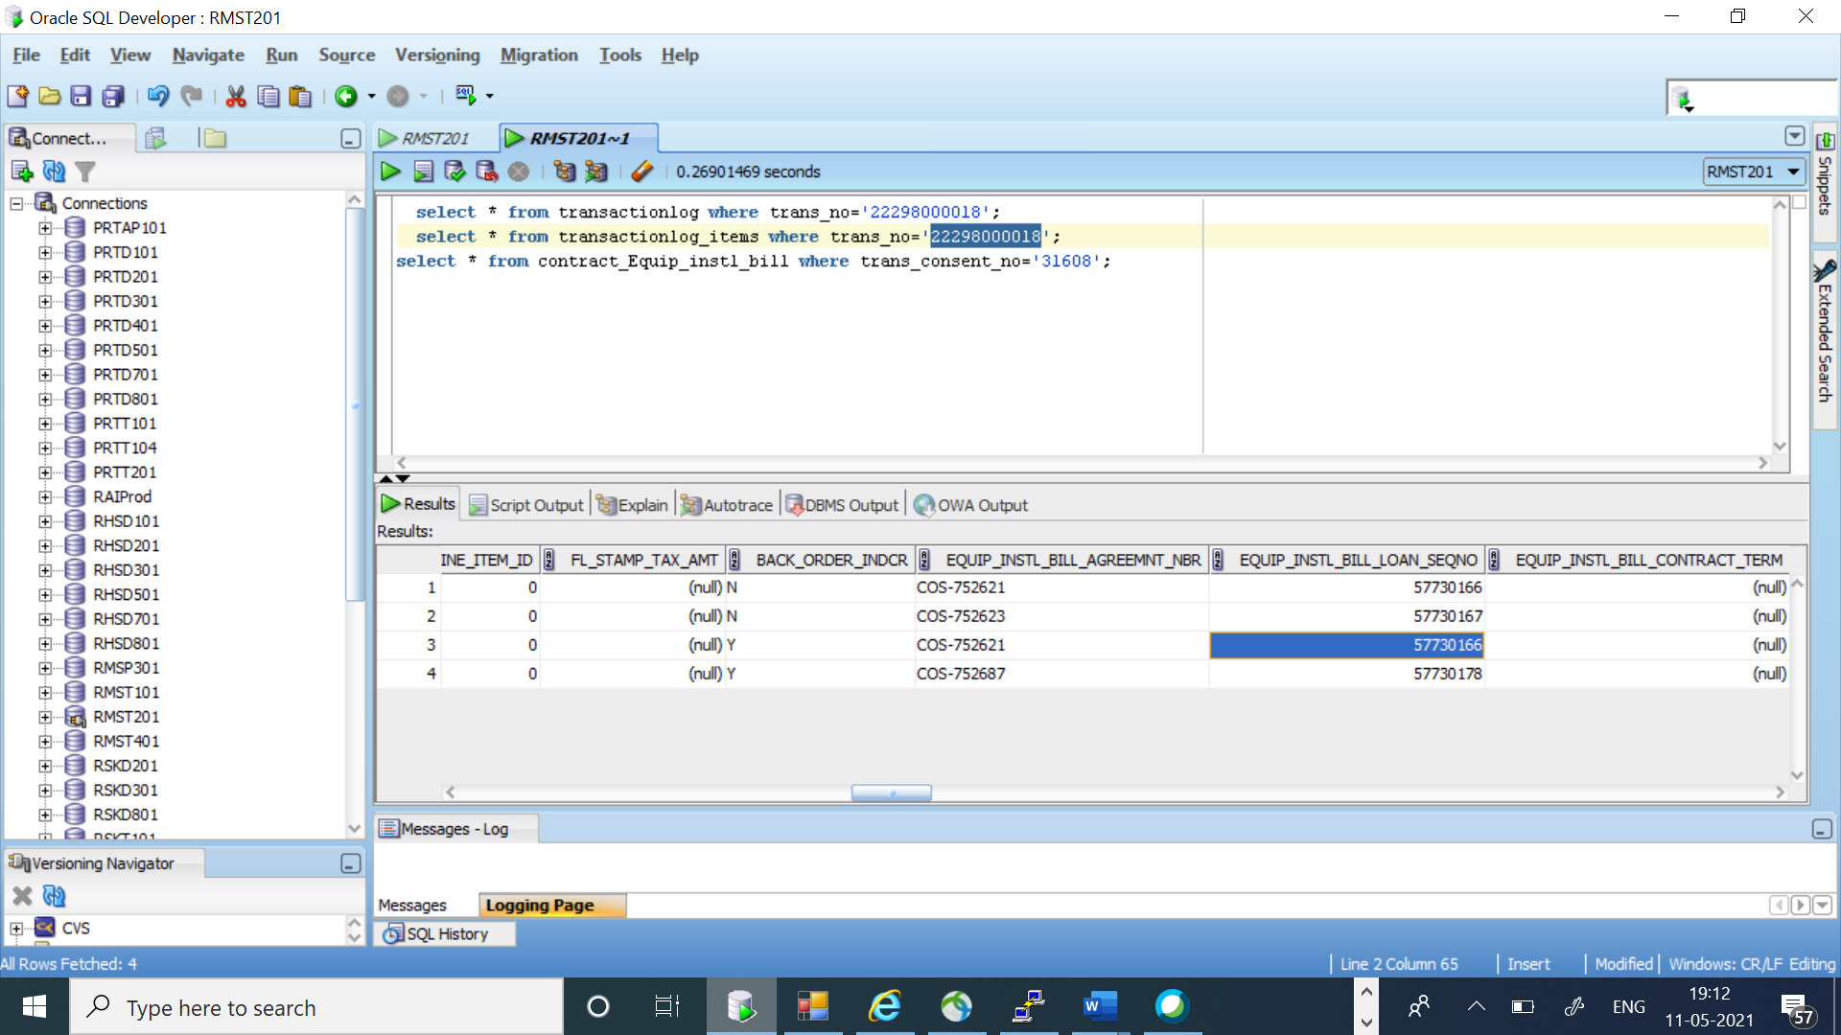

20210511|05:45:56.304|tvmkb141.test.sprint.com|CALL|RET01A2T|AMD.ARM.APPLY_REBATE|RASHMI|0|[B@6c2290f0|148

20210511|05:45:56.305|tvmkb141.test.sprint.com|PROCESS|XXXX|AMD.ARM.APPLY_REBATE|RASHMI|0|RHS:xxxxxxxxx|0|150

20210511|05:46:03.636|tvmkb141.test.sprint.com|CALL|RET01A2T|AMD.ENSEMBLE.UPD_SUB_EQUP|RASHMI|0|[B@30575c1|7328

20210511|05:46:03.636|tvmkb141.test.sprint.com|PROCESS|XXXX|AMD.ENSEMBLE.UPD_SUB_EQUP|RASHMI|0|RHS:xxxxxxxxx|0|7329

20210511|05:46:03.960|tvmkb141.test.sprint.com|CALL|searchLoan|RASHMI|0|RHS:761973087|323

20210511|05:46:03.961|tvmkb141.test.sprint.com|PROCESS|searchLoan|RASHMI|0|RHS:761973087|0|324

20210511|05:46:04.863|tvmkb141.test.sprint.com|CALL|updateLoan|RASHMI|0|RHS:370370012|901

20210511|05:46:04.864|tvmkb141.test.sprint.com|PROCESS|updateLoan|RASHMI|0|RHS:370370012|0|902

20210511|05:46:05.251|tvmkb141.test.sprint.com|CALL|createLoan|RASHMI|0|RHS:718687236|384

20210511|05:46:05.252|tvmkb141.test.sprint.com|PROCESS|createLoan|RASHMI|0|RHS:718687236|0|385

20210511|05:46:05.398|tvmkb141.test.sprint.com|CALL|RET01A2T|AMD.ARM.APPLY_REBATE|RASHMI|0|[B@4737f582|145

20210511|05:46:05.398|tvmkb141.test.sprint.com|PROCESS|XXXX|AMD.ARM.APPLY_REBATE|RASHMI|0|RHS:xxxxxxxxx|0|146

20210511|05:46:11.997|tvmkb141.test.sprint.com|CALL|RET01A2T|AMD.ENSEMBLE.UPD_SUB_EQUP|RASHMI|0|[B@6958ccc9|6597

20210511|05:46:11.998|tvmkb141.test.sprint.com|PROCESS|XXXX|AMD.ENSEMBLE.UPD_SUB_EQUP|RASHMI|0|RHS:xxxxxxxxx|0|6599

20210511|05:46:12.297|tvmkb141.test.sprint.com|CALL|searchLoan|RASHMI|0|RHS:576721331|297

20210511|05:46:12.298|tvmkb141.test.sprint.com|PROCESS|searchLoan|RASHMI|0|RHS:576721331|0|299

20210511|05:46:12.785|tvmkb141.test.sprint.com|CALL|updateLoan|RASHMI|0|RHS:944003625|486

20210511|05:46:12.786|tvmkb141.test.sprint.com|PROCESS|updateLoan|RASHMI|0|RHS:944003625|0|487

20210511|05:46:13.722|tvmkb141.test.sprint.com|CALL|UpdatePOSTransaction|RASHMI|0|RHS|1620726373722

20210511|05:46:13.722|tvmkb141.test.sprint.com|PROCESS|UpdatePOSTransaction|RASHMI|0|RHS|0|1620726373722

2